|  |
| --- |
| https://lh4.googleusercontent.com/nRwuY3LWiWAKeNp-AVHTDhh11aRGLhpfkB_RSTjtBNnGK2vWz-QP2MzAdIB8X45cRWElbfBuNJOKAU62U_tAiButN1aNjgnIrjWGEEaA0On1IEqZ1DSQmMQqCru-c9xGi3ZDM6j- https://lh6.googleusercontent.com/_76v_5LdJoGbV1vxxWmEB2CehGHHM67qkDLr8YaEKKFOjimqPvHyAJWxj622DFMtYcctLR_L34ebRRgG1R6Lvr3BxqdIA38-MkvoIhjJbD0mG09B3-IwnfG-VWCPNUDnCftOMbiR https://lh4.googleusercontent.com/H_Dt0o5lYLGAFzfd9msP4a8yqJRbopRiL5jLVizevBxN6N2nDManUedEcU42_XBJ3MpD3uzMkCvyTTlJVZeGgsQhf3NgW0hoFZJj2TzTOLgD2U2ZvgNezLj3igXq04KlnyxvvD38 https://lh4.googleusercontent.com/fhcWQ9nO25yOsbEZOEx-YdAklsP1mUFCe44mpgWN4IgSaaLcBIrjILI76K9UXDFp6_CMn-Yu49IHYkBBQOrkPvr9AEjxArWfWWwy-ol415FjE3o7r2Zzk2vj2VGOn3wtP5kJFqLt https://lh6.googleusercontent.com/ub7EA-0ha_3pnt53LB3fDlv0eqolWxzYcWXfXC5CsFqE6AC262RGvX_gbvCKYBoJ-1j2cGezxEElGFXXmu2lTYUhBm86lLo1juiOpTtVrcNHEkAfo95o8kUD2JsW9cOmhs94fpGC https://lh5.googleusercontent.com/VlxATMCdt8Dmue98kZCiS6cuP99IdWon2IyWDJOHzL2-8bjV7Gy0CFs0YFTz4RGiR39_LSzNZMm1uYc_KeQtJSqY5_sm31Z21WiYyvViyP2h8mNOpoG9zXQ58MmL43yqMKKqgnWp https://lh3.googleusercontent.com/rFA8LnsFXvOtbh3uh0UT9fupMTf31KWfcBA-Js3RmAdkl_HtIB2pqbMTND8iuqP0xQR-o3bz3KIs9LiiX83Yr2d3SMCBauRFnIGyQMXhr6c40p4nS3Ob_KWDSSxFQcOvuokODDnX https://lh6.googleusercontent.com/ejtcGjgzYQ500IbEUoI-AQSHOGU8SaeED7v-BowIYGAH3QNVpmM6BXRSmUFgaPoVeJVdoRMWJMWlWw3-DRldOZA8MD7jPIYTPmlSly1w6Wq7cWtj_AlddiZZ7euSH3yoFAnCDkhl |

**Biomes & Food Security – Knowledge Revision**

1. What is a biome?  
   A biome is a place on earth characterized by its climate and landscape
2. Identify the eight main biomes, their location and key features (Biomes Summary Google Doc).

|  |  |  |
| --- | --- | --- |
| **Biome Type** | **Features (climate, flora and fauna)** | **Location (longitude / latitude)** |
| Desert | Arid land with little rainfall, vegetation and extreme temperature |  |
| Boreal Forest | Cold forest with frosted soil with coniferous plants |  |
| Grassland | Flat plains with little trees and varying temperature and average rainfall |  |
| Temperate Forest | Mild forest with seasonal plants |  |
| Polar Lands | Very Cold With little vegetation |  |
| Tundra | Perma Frost Plains with little vegetation |  |
| Rainforest | High rainfall forest with evergreen trees |  |
| Mountain Vegeation | Small Shrubs with high wind, high altittude and very cold |  |

1. Describe the climate of the rainforest biome.  
   High temperature with mild changes in summer and winter. very humid and has high rainfall
2. What is leaching? How does it affect the quality of soil in the rainforest biome? (52 – 53 and diagram from exercise book)  
   Rainfall dragging nutrients from the top soil to the bottom soil. This means that trees and plants must have long roots
3. What other kinds of human interference affect the quality of soil in the rainforest biome? (52 – 53)  
   Clearing causes further soil degradation and erosion
4. What are the four stages of soil development and what happens during each stage? (64 – 65 and diagram from exercise book)

|  |  |
| --- | --- |
| **Stage** | **Description** |
| *1* | Rock Begins to degrade |
| *2* | Organic Matter helps degrade |
| *3* | Horizons Form |
| *4* | Supports thick vegetation |

1. What is the difference between intensive and extensive farming? (66 – 67)  
   Extensive farming spread across lots of land and not dense intensive is the opposite
2. What are the four types of rice growing methods? In your own words, explain which method you think is the most productive. (70 – 71)

Irrigated Rice Because it has the highest yeild

Irrigated rice

Rainfed rice

Upland rice

Flood-prone rice

1. What are the six factors that affect food insecurity? Write a short description for each which explains how this factor impacts on whether a country/population has food or not. (98 – 113)

|  |  |
| --- | --- |
| **Factor** | **Description** |
|  |  |
|  |  |
|  |  |
|  |  |
|  |  |
|  |  |

1. Which risk factors could be affecting food security in the Horn of Africa, particularly Somalia? (96 – 97)  
   ____________________________________________________________________________________________________________________________________________________________________________________________________________________________________________________________________________________________________________________________________
2. What are the three key elements to improving food security? (116 – 117)  
   __________________________________________________________________________________________________________________________________________________________________
3. Recall three ways that armed conflicts can impact local farmers. (112)  
   __________________________________________________________________________________________________________________________________________________________________
4. How do landmines contribute to food insecurity? (112 – 113)  
   __________________________________________________________________________________________________________________________________________________________________
5. How do indigenous farmers in South America overcome issues surrounding water scarcity and soil nutrient depletion? (118 – 119)  
   __________________________________________________________________________________________________________________________________________________________________
6. What are the three key principles of conservation agriculture? Include descriptions of how each principle promotes sustainable farming (e.g. why they are useful practices). (122 – 123)

|  |  |
| --- | --- |
| **Principle** | **Description** |
|  |  |
|  |
|  |  |
|  |
|  |  |
|  |

**Word Search – Biomes & Food Security Key Terms**

T T I R M N K P Q P A T T E R N V S L Z Y E F N G

E R U T A R E P M E T L L A F N I A R V T D U F M

T Y U N E I N V B Y C A I W X L M J U A I T R E D

C S F E D U N W O V Z O I O J A Z S M K R S W M A

B F E I L R P K F R F W K Q S F M I U I U W L F R

M G H R T G A M Z Y X U R I I X L D E O C H P X C

G A Y O O N R R D J G N M B I C A N A Q E A T O F

D D W K V F A C V I D H U R C D T L P S S W K K M

C E U H A S N U Q V N C A O B E U O B B T F T C L

Q F F L D A C I Q P B G N K R S B W H F X C L Q J

Q H U E B I Y R A Z E S B S W E N A B D H T I M L

V N R U S O X C D R E R W W F R I I G R C C E O T

R Y Z F S K D J U R R F S D R T O F I U J N G W Z

H H T G U A A I V D K D T U G M C D V Z R H W R M

J G V K W H A A X G N P D S E Q L W C B Q H C Q N

N Y J H G Y T W L A H P D F C U Q L S J I K L A V

O W N X I I E H L M Y I A Y W D S E I H M R Y A W

I Y X V O O V S E X C E P T I O N A W P J Z Q T U

T N A N Q D S N Y L P X Q A Z P K C V K X X K B K

A F N X L A T B B B Y Y J J N V T H E A M C A Q Q

T K S I R B V E C S D S J M M D D I H V N Y F X T

P G N G N K Z Q Q F I G Z T L H Z N K J X N J B H

A U W G Y C H F K Z B S W B O I B G P A C N A E R

D D K Q C T K G O R Z A E M T H T O G W G Z W H V

A E T A G R K R M K U Z M Z Y H M K N H T C D M B

ADAPTATION

BIOME

CLIMATE

CONSERVATION

DESERT

EXCEPTION

FUEL

GRASSLAND

LEACHING

NUTRIENT

PATTERN

QUANTIFY

RAINFALL

RAINFOREST

RISK

SAVANNAH

SECURITY

SOIL

TEMPERATURE

TUNDRA

**Biomes & Food Security – Skills Revision**

1. Use the information in the table to complete a climate graph of Innisfail:

|  |  |  |  |  |  |  |  |  |  |  |  |  |
| --- | --- | --- | --- | --- | --- | --- | --- | --- | --- | --- | --- | --- |
| **INNISFAIL 17.5°S 153°E** | | | | | | | | | | | | |
| **Month** | *J* | *F* | *M* | *A* | *M* | *J* | *J* | *A* | *S* | *O* | *N* | *D* |
| **Temp. (°C)** | 31 | 30.5 | 30 | 28 | 26.5 | 24.4 | 24 | 25 | 27 | 28.5 | 30 | 31 |
| **Rainfall (mm)** | 506 | 597 | 659 | 466 | 301 | 188 | 133 | 119 | 86 | 83 | 155 | 262 |

____________________________________________________



***Answer the following in paragraphs:***

1. What is the climate pattern of Innisfail? Refer to the information in your climate graph in your response.
2. Which biome is most commonly found in Innisfail? Explain the features of this biome, and why it is found here.

***Refer to the sources below (also on page 114 of textbook):***

***Source 1 – Proportion of undernourished people by region/year***

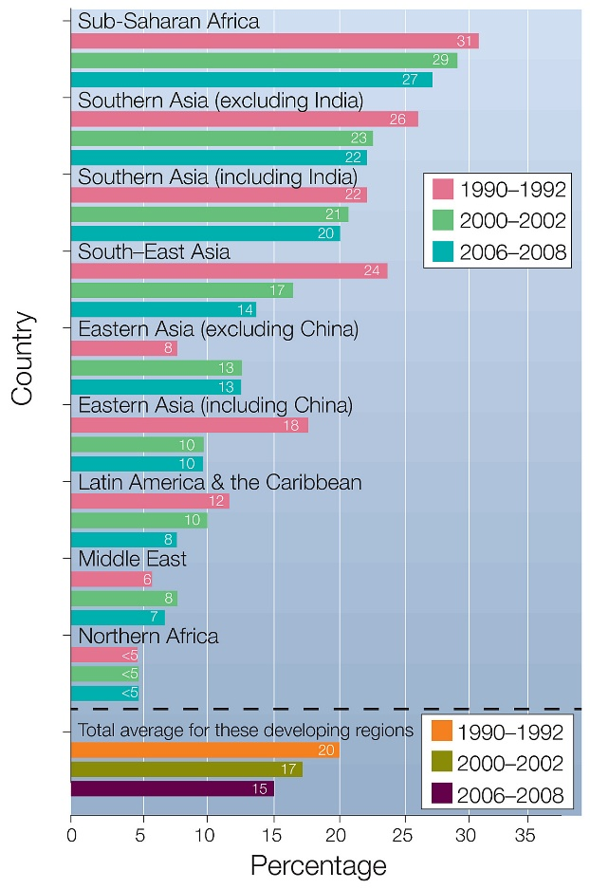

***Source 2 – World Hunger Levels (2012)***

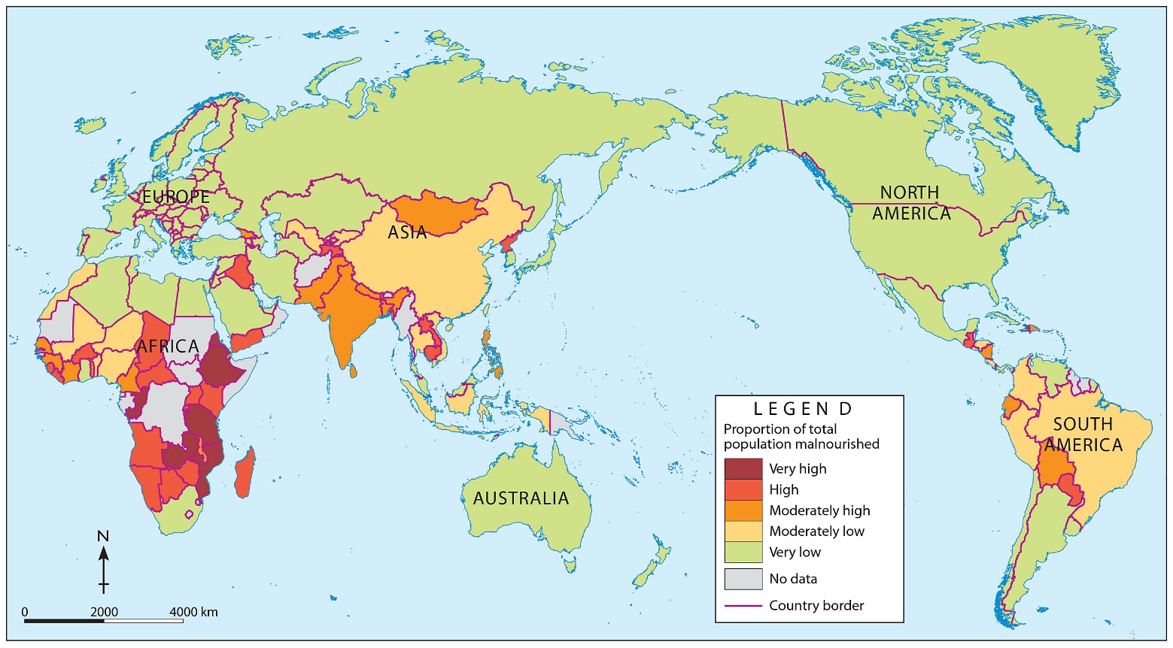

1. Using the PQE method, write a paragraph that identifies the patterns and exceptions to the world hunger data shown in both sources.
2. What reasons can you give as to why certain regions are highly malnourished, and others are not?